On the Beat in
Bridgnorth and Rural East
Safer Neighbourhood Team |  |  |  |  |  | November 2022
Where we Work
The Safer Neighbourhood Team are based in Bridgnorth Police Station, Wenlock Road, Bridgnorth, Shropshire, WV16 5BB. We work in Bridgnorth, and the parishes of Alveley Claverley Worfield and Ackleton.
Team contact details
Team email: bridgnorth.snt@westmercia.pnn.police.uk
Safer Neighbourhood Officer | Police Community Support Officer |  | Police Community Support Officer |  |  |  | Police Community Support Officer
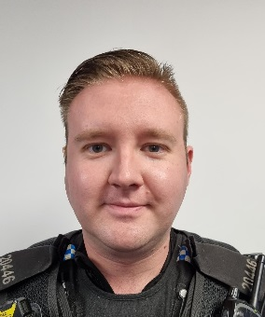 | 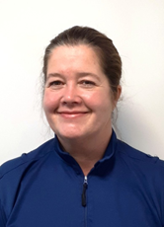 |  | 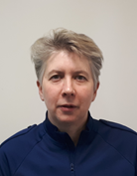 |  |  |  | 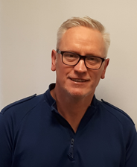
PC Jono Lightfoot | PCSO Mandy Leek |  | PCSO Helen Oakley |  |  |  | PCSO Stephen Dunn-Brown
07811761855 | 07816236749 |  | 07816237839 |  |  |  | 07814053796
Police Contact Details
Emergency: 999 |  |  |  | Website: www.westmercia.police.uk
Non Emergency: https://www.westmercia.police.uk/ |  |  |  | Twitter: @Bridgnorthcops
Crime stoppers: 0800 555 111 or
https://crimestoppers-uk.org/give-information/forms/give-information-anonymously
Facebook: Shropshire Cops
This monthly newsletter aims to bring you news of Police activity in your local area, events that the team have attended or are hoping to attend and useful information, such as crime prevention advice. We hope it is of use and would like to hear from you if you have any ideas on what to include or how we can improve this publication. We look forward to hearing from you.
Sign up to Neighbourhood Matters … your brand new community messaging service
 |  | Neighbourhood Matters enables residents, businesses and community groups to keep in touch with local policing teams. You can choose exactly what type of alert you wish to receive and how you receive them; whether that be by email, text or telephone. Sign up now at: www.neighbourhoodmatters.co.uk
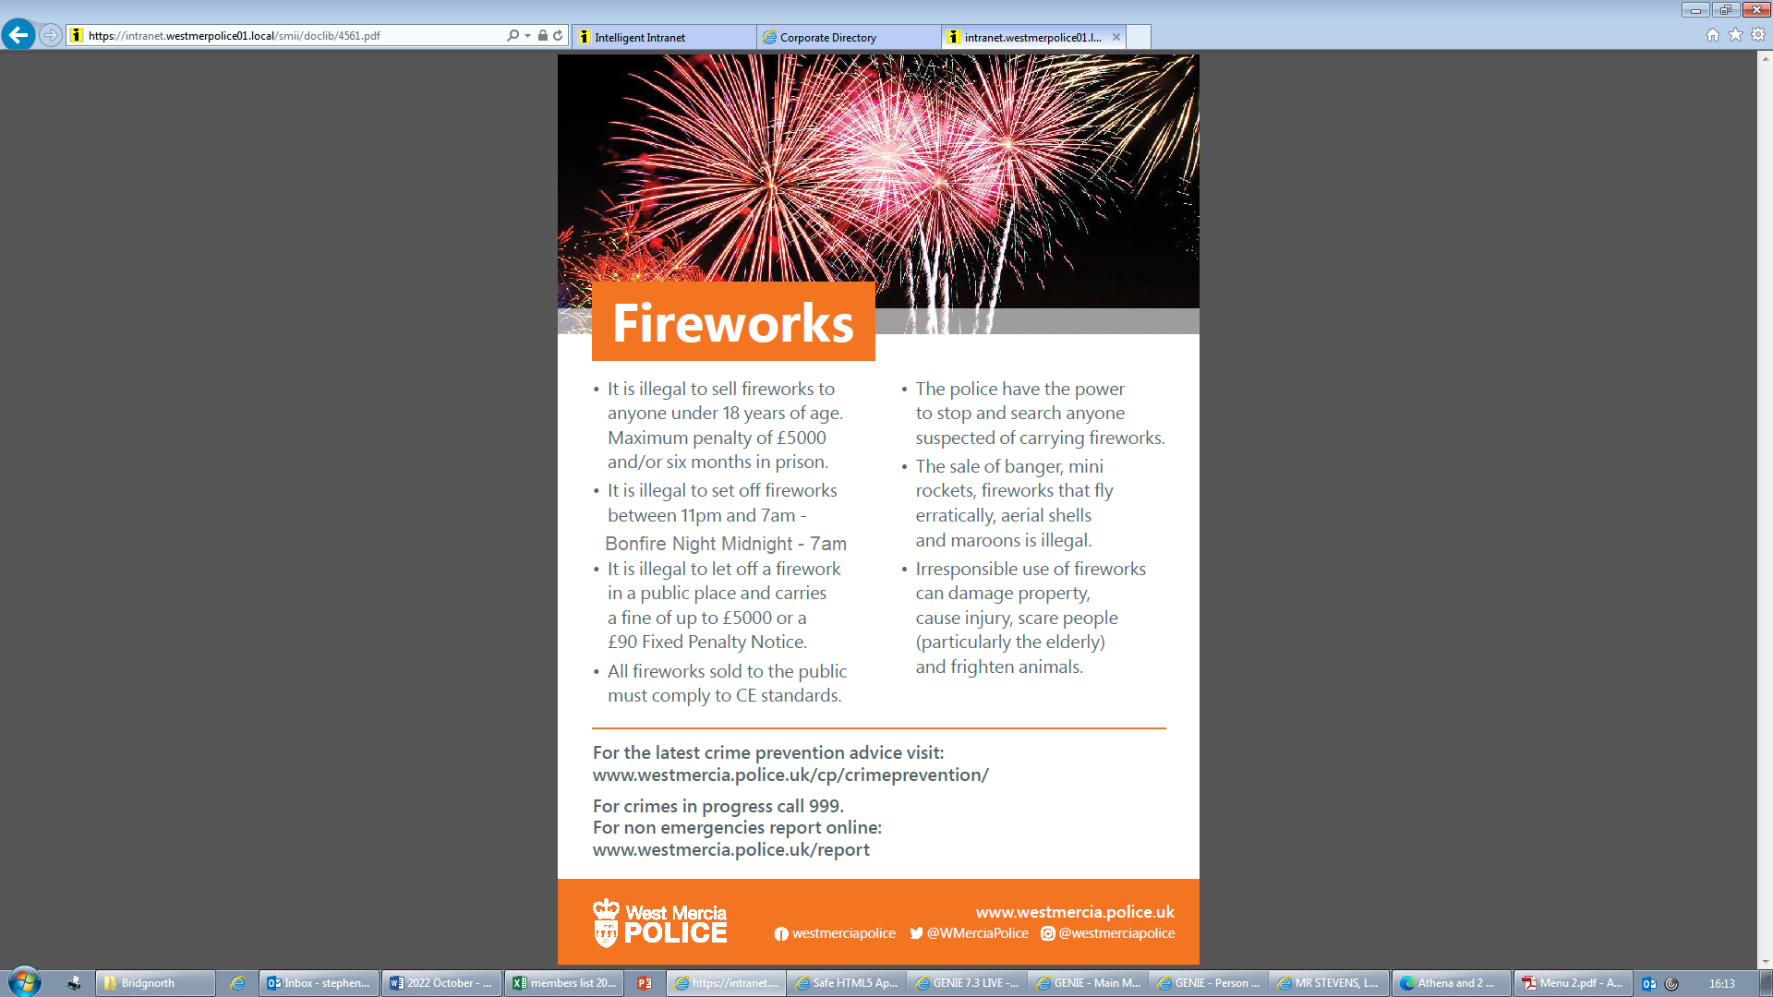 |  |  |  |  | 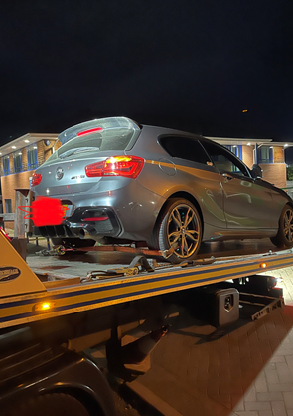  Anti-Social Driving in Bridgnorth. On Sunday the 9th of October, Officers witnessed a car being driven in an anti-social manner. Officers seized the vehicle using Section 59 powers. Under this power, the registered keeper has to pay for the return of the vehicle. We are continuing to monitor the vehicle and will take further action as necessary.
Dates for the diary.    9/11 - 1pm Hate crime presentation to yrs 10 & 11 at Bridgnorth Endowed school.  12/11 – 6pm Claverley bonfire.  13/11 - Remembrance  14/11 - 10am Veterans outreach Bridgnorth library.  16/11 – 2:30pm Pact surgery Bridgnorth library.  25/11 – 4pm-8pm Christmas light switch on. |  |  |  | Hate Crime Presentation  During October PC Lightfoot attended Oldbury Wells School and spoke to ALL years about the seriousness of Hate crimes and Hate incidents. He pointed out what action the police would take if anyone is reported / caught committing a Hate Crime. 

