Quatt Malvern Parish Council Accounts Final 2020-21
ITEM

Receipts

Payments

Balances b/f | 12880.10
Precept | 6000.00
Clerks Salary | 1882.12
PAYE Income Tax | 468.40
Travel Expenses | 43.70
Telephone/ Internet |  | 100.00
Postage
Stationery
Computer S/W Licences |  | 28.78
Computer consumables |  | 106.00
Councillors expenses
Seminar fees
Cou nc il Room hire
Parish meeting
Insurance |  | 174.62
Audit fees |  | 60.00
Village gateways
Community led Plan |  | 242.44
GRANT/ DONATIONS:
Quatt Cricket Club
Contingency
Quatt Bell Ringers
Village Hall Grants
Hope House |  | 250.00
SECTION 137: [£1592]
P.C.C. St. Andrews
Churchyard Grass Cutting |  | 40.00
Remembrance Wreath |  | 150.00
Other 137 / Contingency
Smartwater |  | 90.00
Samaritans
MIND
SUBSCRIPTIONS:
SALC |  | 155.18
Pu bli cations
Mobile Library
MISCELLANEOUS:
Notice Boards
Election Expenses
Advertising/ Publicity
Grass cutting/ maintenance
Pedestrian Refuge
Registration with I.C.0 |  | 40.00
BOAT Works
Maintenance of Church Clock |  | 571.20
Zoom Apportion with TPC |  | 34.51
VAT Refund | 49.38
Bank Interest | 6.50
 | 18935.98 | 4436.95
Closing Balances in Bank Account |  | 14,499.03
transfer to balances
 | 18935.98 | 18935.98

Signed by William Steffan Griffiths
Clerk and Responsible Financial officer 7.04.2021



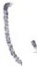
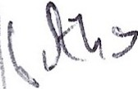
- )

__.. . -.-··

... --

Bank Reconciliation Quatt Malvern Parish Council Financial Year Ending
31 March 2021

Prepared By William Steffan Griffiths, Clerk and Responsible Financial Officer 5th April 2021

Balance as per Bank Statements at 31 March 2021

Community Account: -£1131.20

Business Money Manager Account: £13,367.83

Cash in hand: N/A
Unbanked Cash at 31.03.2021 NIL

Less Unpresented Cheques as at 31 March 2021

NIL

Balances as at 31st March 2021 £14499.03

Reconcile to the cash book (Receipts and Payments Account) as follows:

Cash Book
Opening balance 1st April 2020

+Receipts in the Year Less Payments in the year

£12,880.10
£ 6,055.88
£ 4436.95

Closing balance per cash book as at 31st March 2021 £14,499.03

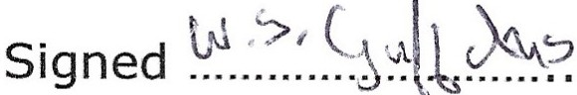
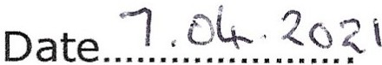

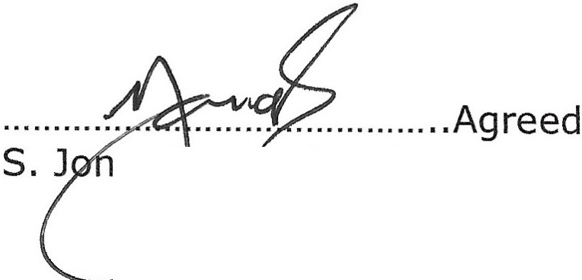
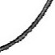

es,I ternal Auditor
Date...f.J.....7.....'-..{....t... tl

Steve Jones
Bu sin ess Consultant
72 Manor Avenue South, Ki d d er m in st er , Wares DYll 6DG
01562 753828 - st5v5jon5s@gmail.com

W Griffiths
Quatt Malvern Parish Council 9 Stretton Close
Bridgnorth WV16SDB
Your Ref: Our Ref:

27 April 2021

Dear Bill

Annual Examination

I am pleased to advise that there were no issues to report following this year's examination -well done and thank you for presenting the information in a manner which facilitates the work I need to do.

I have adopted a slightly more relaxed approach this year as I am well aware of the difficulties we have all encountered with the restrictions placed on us by the continuing pandemic. That said, I am happy that all payments have been properly authorised and minuted.

Once again, many thanks for your help. With kind regards,
Yours sincerely
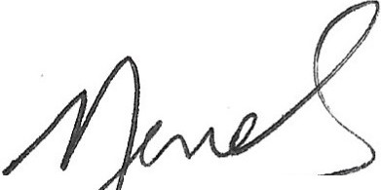
S ones

ess Consultant

Annual Internal Audit Report 2020/21

QUATT MALVERN PARISH COUNCIL

quattpc.org.uk

During the financial year ended 31 March 2021, this authority's internal auditor acting independently and on the basis of an assessment of risk, carried out a selective assessment of compliance with the relevant procedures and controls in operation and obtained appropriate evidence from the authority.
The internal audit for 2020/21 has been carried out in accordance with this authority's needs and planned coverage. On the basis of the findings in the areas examined, the internal audit conclusions are summarised in this table.
Set out below are the objectives of internal control and alongside are the internal audit conclusions on whether, in all significant respects, the control objectives were being achieved throughout the financial year to a standard adequate to meet the needs of this authority.

- Appropriate accounting records have been properly kept throughout the financial year.
- This authority complied with its financial regulations, payments were supported by invoices, all expenditure was approved and VAT was appropriately accounted for.
- This authority assessed the significant risks to achieving its objectives and reviewed the adequacy of arrangements to manage these.
- The precept or rates requirement resulted from an adequate budgetary process; progress against the budget was regularly monitored; and reserves were appropriate.
- Expected income was fully received, based on correct prices, properly recorded and promptly
banked; and VAT was appropriately accounted for. /
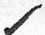
- Petty cash payments were properly supported by receipts, all petty cash expenditure was approved and VAT appropriately accounted for.
- Salaries to employees and allowances to members were paid in accordance with this authority's approvals, and PAYE and NI requirements were properly applied.
- Asset and investments registers were complete and accurate and properly maintained.
- Periodic bank account reconciliations were properly carried out during the year.
- Accounting statements prepared during the year were prepared on the correct accounting basis (receipts and payments or income and expenditure), agreed to the cash book, supported by an adequate audit trail from underlying records and where appropriate debtors and creditors were properly recorded.
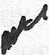
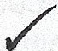
- If the authority certified itself as exempt from a limited assurance review in 2019/20, it met the exemption criteria and correctly declared itself exempt. (If the authority had a limitecf assurance review of its 2019/20 AGAR tick "not covered")

- The authority publishes information on a website/webpage, up to date at the time of the internal audit, in accordance with the Transparency code for smaller authorities.
- The authority, during the previous year (2019-20) correctly provided for the period for the exercise of public rights as required by the Accounts and Audit Regulations (evidenced by the notice published on the website and/or authority approved minutes confirming the dates set).
- The authority has complied with the publication requirements for 2019/20 AGAR
(see AGAR Page 1 Guidance Notes).

0. (For local councils only)
Trust funds (including charitable) - The council met its responsibilities as a trustee.
For any other risk areas identified by this authority adequate controls existed (list any other risk areas on separate sheets if needed).

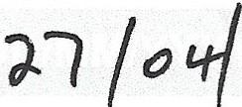
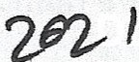
Date(s) internal audit undertaken
Signature of person who carried out the internal audit
Name of person who carried out the internal audit
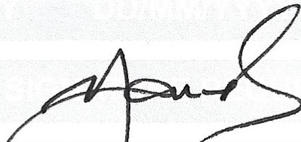
9i_. Jo/0+>
r:2--, -f 2fYll
Date

*If the response is 'no' please state the i plication and action being taken to address any weakness in control identified (add separate sheets if needed). 
**Note: If the response is 'not covered' please state when the most recent internal audit work was done in this area and when it is next plannep; or, if coverage is not required, the annual internal audit report must explain why not (add separate sheets if needed).

Annual Governance and Accountability Return 2020/21 Part 2
Local Councils, Internal Drainage Boards and other Smaller Authorities
Page 4 of6

-

Certificate of Exemption - AGAR 2020/21 Part 2

To be completed by smaller authorities where the higher of gross income or gross expenditure did not exceed £25,000 in the year of account ended 31 March 2021, and that wish to certify themselves as exempt from a limited assurance review under Section 9 of the Local Audit (Smaller Authorities) Regulations 2015
There is no requirement to have a limitedassurance review or to submit an Annual Governance and Accountability Return to the external auditor, provided that the authority has certified itself as exempt at a meeting of the authority after 31 March 2021 and a completed Certificate of Exemption is submitted no later than 30 June 2021 notifying the external auditor.

QUATT MALVERN PARISH COUNCIL

certifies that during the financial year 2020/21, the higher of the authority's total gross income for the year or total gross annual expenditure, for the year did not exceed £25,000
Total annual gross income for the authority 2020/21: £6,056

Total annual gross expenditure for the authority 2020/21: £4,437
,
There are certain circumstances in which an authority will be unable to certify itself as exempt, so that a limited assurance review will still be required. If an authority is unable to confirm the statements below then it cannot certify itself as exempt and it must submit the completed Annual Governance and Accountability Return Part 3 to the external aµditor to undertake a limited assurance review for which a fee of £200 +VAT will be payable.
By signing this Certificate of Exemption you are confirming that:
- The authority was in existence on 1st April 2017
- In relation to the preceding financial year (2019/20), the external auditor has not:
  - issued a public interest report in respect of the authority or any entity connected with it
  - made a statutory recommendation to the authority, relating to the authority or any entity connected with it
  - issued an advisory notice under paragraph 1(1) of Schedule 8 to the Local Audit and Accountability Act 2014 ("the Act"-); and has not withdrawn the notice
  - commenced judicial review proceedings under section 31(1) of the Act
  - made an application under section 28(1) of the Act for a declaration that an item of account is unlawful, and the application has not been withdrawn nor has the court refused to make the declaration
- The court has not declared an item of account unlawful after a person made an appeal under section 28(3) of the Act.
If you are able to confirm that the above statements apply and that the authority neither received gross income, nor incurred gross expenditure, exceeding £25,000, then the Certificate of Exemption can be signed and a copy submitted to the external auditor either by email or by post (not both).
The Annual Internal Audit Report, Annual Governance Statement, Accounting Statements, an analysis of variances and the bank reconciliation plus the information required by Regulation 15 (2), Accounts and Audit Regulations 2015 including the period for the exercise of public rights still need to be fully completed and, along with a copy of this certificate, published on the authority website/webpage* before 1 July 2021.
By signing this certificate you are also confirming that you are aware of this requirement.

Signed by the Responsible Financial Officer Date

Signed by Chairman Date
I confir111 that this Certificate of Exemption was approved by this authority on this date:
as recorded in minute reference:

Generic email address of Authority Telephone number
• •

.
*Published web address ••

quattpc.org.uk
ONLY this Certificate of Exemption should be returned EITHER by email OR by post (not both) as soon as possible after certification to your external auditor, but no later than 30 June 2021. Reminder letters incur a charge of £40 +VAT

Annual Governance and Accountability Return 2020/21 Part 2
Page 3 of6

-

Section 2 - Accounting Statements 2020/21 for

QUATT MALVERN PARISH COUNCIL

Year ending Notes and guidance
31 March
31 March
Please round all figures to nearest £1. Do not leave any
· 2020 2021 _
boxes blan/( and report £0 or Nil balances. All figures n1ust
£ £ agree to lJnderlying financial records.
1. Balances brought forward
1. Balances brought forward | 12,054 | 12,880 | Total balances and reserves at the beginning of the year  as recorded in the financial records. Value must agree to Box 7 of previous year.
2. (+)Preceptor Rates and  Levies | 5,930 | 6,000 | Total amount of precept (or for IDBs rates and levies) received or receivable in the year. Exclude any grants received.
3. (+) Total other receipts | 75 | 56 | Total income or receipts as recorded in the cashbook less the precept or rates/levies received (line 2). Include any grants received.
4. (-) Staff costs | 2,288 | 2,494 | Total expenditure or payments made to and on behalf of all employees. Include gross salaries and wages, employers NI contributions, employers pension contributions, gratuities and severance payments.
5. (-) Loan interest/capital  repayments | 0 |  | Total expenditure or payments of capital and interest
5. (-) Loan interest/capital  repayments | 0 | 0 made during the year on the authority's borrowings (if any).
6. (-) All other payments | 2,891 | Total expenditure or payments as recorded in the cash  1,943 book less staff costs (line 4) and loan interest/capital  repayments (line 5).
7. (=) Balances carried forward | 12,880 | Total balances and reserves at the end of the year. Must  14,499 equal (1+2+3) - (4+5+6).

8. Total value of cash and short term investments | 12,880 | 14,499 | The sum (i)f all current and deposit bank accounts, cash holdings and short term investments held as at 31 March- To agree with bank reconciliation.
9. Total fixed assets plus long term investments and assets | 3,451 | 3,451 | The value of all the property the authority owns - it is made up of all its fixed assets and long term investments as at 31 March.  - - ---· ...
10. Total borrowings | 0 | 0 | The outstanding capital balance as at 31 March of a/I loans from third parties (including PWLB).
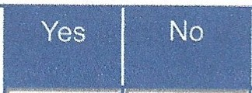
The Council as a body corporate acts as sole trustee for and is responsible for managing Trust funds or assets.
N.B. The figures in the accounting statements above do not include any Trust transactions.
11. (For Local Councils Only) Disclosure note re Trust funds (including charitable)

I certify that for the year ended 31 March 2021 the Accounting Statements in this Annual Governance and Accountability Return have been prepared on either a receipts and payments or income and expenditure basis following the guidance in Governance and Accountability for Smaller Authorities - a Practitioners' Guide to Proper Practices
and present fairly the financial position of this authority.
Signed by Responsible Financial Officer before being presented to the authority for approval

Date
I confirm that these Accounting Statements were approved by this authority on this date:

as recorded in minute reference:

Signed by Chairman of the meeting where the Accounting Statements were approved

Annual Governance and Accountability Return 2020/21 Part 2
Page 6 of 6

Explanation of variances - pro forma

Name of smaller authority:
QlJ lj T'M; A· li lRNi.P:Af!{J
S
G:J;JW II .;
County area (local councils oind
Insert figures from Section 2 of the AGAR in all Blue highlighted boxes

Next, please provide full explanations, including numerical values, for the following that will be flagged in the green boxes where relevant:
- variances of more than 15% between totals for individual boxes (except variances of less than £200);
- New from 202012:1variances of £100,000 or more require explanation regardless of the % variation year on year;
- a breakdown of approved reserves on the next tab if the total reserves (Box 7) figure is m ore than twice the annual
precept/rates & levies value (Box 2).
J AutomatiG r esp0rtses trigger b:eJ0w 0a·se0 on figrnres
lir}p_ t1 li>_O NOT C>VERV<l l 'rE TlilE'SE B©l<E, S _
0
Exp anation from smaller authority (must include narrative and suppo_rting figures)

2019/20
£

2020/21
£

Variance Variance
£ %
Explanation Required?

- BalancesBrought Forward

1'2,054

1'2\ 880'

Explanation 0f % variance frbm l?Y 0we aingJ l!>alanee:n0! reguiredl• Balance brolli ht forward·agre,es

- Precept or Rates and Levies I 5,932'J L_11,_<ro.o• J 70 1.18% NO

- Tolal Other Receipts

: 1 75, I I 56 I -19 25.33% YES
-
,Explanationnot reqµire0, differenee·less,Iha e20, ©

- Staff Costs
·1 2 ; 288' ! I 2, 4.94. 1

206 9.00% NO

- Loan lnteresUCapital Repayment I O' I r 0 I 0 0 .00 % NO I '

- All Other Payments
[: 2,891 I I
1,943 I

·948 32.79% YES
II.. ._ __ Jsee Appendix to Explanation of Variances 2020-21


- Balances Carried Forward 12,880 1 I 14,499 J [ YP1RJ/1l!'-l,C1$ !,J( ,rJqr't.©TRiE¢ltJlRIElD _
I
. E XPLA'Nl«;iJt:oNIR'EQJ!JI RED• ©Nl RESERVES:T/!18 A'S
TO•WAIi'. .e'ARRYFOIRWARD;RESER!El :SfAIRe GREA,1iER' Tlil\ll!NI 'liW,I.G:E ING:OMEil'R©M' LOC'Ali!
YES 11 'JIAX, ATl©'N/,llE :ltlE. S I

- Total Cash and Short Term Investments 1 1 12,880 I 1

14 , 49 9 1
,VARW!.WCE IEXIPl!.A>b1161; tl(l111 NOJF RJEQIJIF<lll!O '
., •...-,r, -
-

- Total Fixed Assets plus Other Long Term Investments ani i
3;451 ' I I 3•I451' I

0 0 . 00 % NO
,,.
- ·· --

1O Total Borrowings
Ii O• I I O' I
0 0.00°/4 NO

Rounding errors of up to £2 are tolerable Variances of £200 or less are tolerable

Expla nation for 'high' reserves
(Please complete the highlighted boxes.)
Box 7 is more than twice Box 2 because the authority held the following breakdown of reserves at the year end:

£ £ £
Earmarked reserves:

5000
Reserve 1
Reserve 2
Reserve 3
Reserve 4
Reserve 5
3500
Provision of pedestrian refuge in Quatt Village
Provision of Vehicle activated speed sign in Quatt Vill age.

Reserve 6
Reserve 7

8500

General reserve

Total reserves (must agree to Box 7)

5999

5999

14499

'·

-

Audit 2020-21 Quatt Malvern Parish Council Explanation of Variances - Appendix

Box 6 All Other Payments - £948 decrease from 2019/20 to 20/21

In 2019-20 the Council contributed a one - off payment of £1000 towards traffic calming measures on the parish BOAT (Byeway open to all traffic). There was no such payment in 2020- 21. Apart from this payment, there is no significant variation.
W.S.Griffiths, Clerk and Responsible Financial Officer 7th April 2021

Section 1 - Annual Governance Statement 2020/21

We acknowledge as the members of:

QUATT MALVERN PARISH COUNCIL

our responsibility for ensuring that there is a sound system of internal control, including arrangements for the preparation of the Accounting Statements. We confirm, to the best of our knowledge and belief, with respect to the Accounting Statements for the year ended 31 March 2021, that:


  - We have put in place arrangements for effective financial management during the year, and for the preparation of the accounting statements.

2. We maintained an adequate system of internal control including measures designed to prevent and detect fraud and corruption and reviewed its effectiveness.

prepared its accounting statements in accordance with the Accounts and Audit Regulations.

made proper arrangements and accepted responsibility for safeguarding the public money and resources in
its charge.

has only done what it has the legal power to do and has complied with Proper Practices in doing so.

during the year gave all persons interested the opportunity to inspect and ask questions about this authority's accounts.
4. We provided proper opportunity during the year for the exercise of electors' rights in accordance with the requirements of the Accounts and Audit Regulations.
3. We took all rea.s onable steps to assure ourselves that there are no matters of actual or potential non-compliance with laws, regulations and Proper
Practices that could have a significant financial effect on the ability of this authority to conduct its
business or manage its finances.

considered and documented the financial and other risks it faces and dealt with them properly.
5. We carried out an assessment of the risks facing this authority and took appropriate steps to manage those risks, including the introduction of internal controls and/or external insurance cover where required.

- We took appropriate action on all matters raised in reports from internal and external audit.
6. We maintained throughout the year an adequate and effective system of internal audit of the accounting records and control systems.
- We considered whether any litigation, liabilities or commitments, events or transactions, occurring either during or after the year-end, have a financial impact on this authority and, where appropriate, have included them in the accounting statements.
... --· - --
- (For local councils only) Trust funds including charitable. In our capacity as the sole managing trustee we discharged our accountability responsibilities for the fund(s)/assets, including financial reporting and, if required, independent examination or audit.
arranged for a competent person, independent of the financial controls and procedures, to give an objective view on whether internal controls meet the needs of this smaller authority.
responded to matters brought to its attention by internal and external audit.
disclosed everything it should have about its business activity during the year including events taking place after the year end if relevant.

has met all of its responsibilities where as a body corporate it is a sole managing trustee of a local trust or trusts.

*For any statement to which the response is 'no', an explanation must be published

This Annual Governance Statement was approved at a meeting of the authority on:

and recorded as minute reference:
Signed by the Chairman and Clerk of the meeting where approval was given:

Chairman Clerk
.
Other information required·
'
-·----- - ···
the Transparency Code (not part of the Annual Governance Statement). _
...
. · ---
- ----- ··-·--·--···
'·
The authority website/webpage is up to date and the information required by the Transparency Code has been published.
Yes .INo '
by
.

quattpc.org.uk

Annual Governance and Accountability Return 2020/21 Part 2
Local Councils, Internal Drainage Boards and other Smaller Authorities
Page 5 of 6

