On the Beat in
Bridgnorth and Rural East
Safer Neighbourhood Team |  |  |  |  | August 2023
Where we Work
The Safer Neighbourhood Team are based in Bridgnorth Police Station, Wenlock Road, Bridgnorth, Shropshire, WV16 5BB. We work in Bridgnorth, and the parishes of Alveley Claverley Worfield and Ackleton.
Team contact details
Team email: bridgnorth.snt@westmercia.pnn.police.uk
Safer Neighbourhood Officer | Police Community Support Officer |  | Police Community Support Officer |  |  | Police Community Support Officer
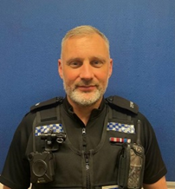 | 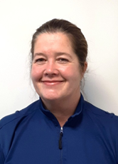 |  | 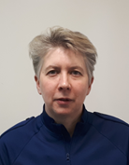 |  |  | 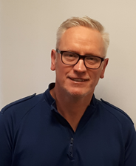
PC Rikki Loftus | PCSO Mandy Leek |  | PCSO Helen Oakley |  |  | PCSO Stephen Dunn-Brown
07967302226 | 07816236749 |  | 07816237839 |  |  | 07814053796
Police Contact Details
Emergency: 999 |  |  |  | Website: www.westmercia.police.uk
Non Emergency: https://www.westmercia.police.uk/ |  |  |  | Twitter: @Bridgnorthcops
Crime stoppers: 0800 555 111 or
https://crimestoppers-uk.org/give-information/forms/give-information-anonymously
Facebook: Shropshire Cops
This monthly newsletter aims to bring you news of Police activity in your local area, including Crime Alerts, positive action that has been taken by the Police, future public meetings and events that the team are hoping to attend and useful information, such as crime prevention advice. We hope it is of use and would like to hear from you if you have any ideas on what to include or how we can improve this publication. We look forward to hearing from you, the team email is the best point of contact.

Sign up to Neighbourhood Matters … your brand new community messaging service
 |  | Neighbourhood Matters enables residents, businesses and community groups to keep in touch with local policing teams. You can choose exactly what type of alert you wish to receive and how you receive them; whether that be by email, text or telephone. Sign up now at: www.neighbourhoodmatters.co.uk
Open Water advice
◻ Stay well away from quarry lakes, fast flowing rivers and weirs (they all have hidden dangers)
◻ Ease yourself in, never jump in
◻ If you spot anyone getting into difficulty DON’T enter the water, dial 999 IMMEDIATELY
Help a dog in a hot car  Establish the animals health and condition. If they are displaying any signs of HEATSTROKE dial 999. You can also call the RSPCA cruelty hotline for advice on 0300 1234 999 |  |  |  |  | Business Break-In’s  There has been a small number of businesses in the Bridgnorth and rural areas that have been broken in to or had an attempted break-in.  Please be vigilant when out and about.
Anti-Social Behaviour (ASB)  During the summer months we have an increase in calls for ASB. Please can everyone take some time to think about how ASB affects individuals and communities.  During July the Safer Neighbourhood team issued 10 Warning letters to young people for causing ASB within the town.  Alveley Country Park – We had been receiving reports from the Ranger about off road bikes using the country park. This has been causing other users of the park Harrassment, Alarm and distress. Extra patrols of this area have been carried out to try and disrupt this ASB |  |  |  |  | Staff changes  We have said goodbye to PS Kate OEN who has moved to another department within the force. The SNT now have PS Steve Grant steering the ship.
Dates for your Diary
Burwarton Show 3rd August All Day
The Bridge Youth Club 4th August 2000-2100
PACT Surgery – Bridgnorth Library 15th August 1500-1600
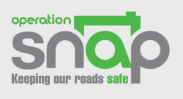
As part of Operation Snap, members of the public can report and submit digital footage showing potential traffic offences via a secure online form. Any offences will be considered including: Speeding, Dangerous or careless driving/cycling, Dangerous driving around other road users, such as horse riders and cyclists ('close passing'), Overtaking on solid white lines, Using a mobile phone while driving, Failing to comply with traffic signs / signals, Using a vehicle in a Dangerous Condition. https://www.westmercia.police.uk/operationsnap

